Udacity Weather Trends Project

Temperatures Trends - Washington, DC vs. Global

Introduction.

We explore weather trends in localized temperatures (city of Washington, DC) against global mean temperature from 1750 to 2013. All temperatures are measured in degrees Celsius.  
We use moving averages to better observe trends.  
The project uses SQL and Python (Pandas and Matplotlib).

Data Collection.

All data was provided by Udacity. To extract a clean data set, we join the global_data and city_data tables on year with parameters to select for location and drop null values:

SELECT gd.year AS "year",

gd.avg_temp AS "global_temp",

cd.avg_temp AS "wash_temp"

FROM global_data AS gd

JOIN city_data AS cd

ON cd.year = gd.year

WHERE cd.city = 'Washington' AND cd.avg_temp IS NOT Null AND gd.avg_temp IS NOT NULL

Moving Averages – Pandas

The data is imported from csv into a data frame with the pandas.read_csv() method.

We then use the rolling() method to create a column with rolling averages from the temperatures like:

df['wash_moving'] = df['wash_temp'].rolling(window=20, min_periods=1)

Figure 1 shows the utility of moving averages. We can observe the general trend easier from the averaged curves.

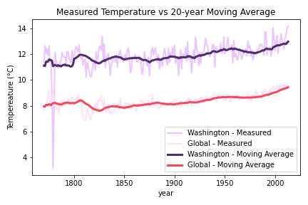

Figure 1 – Moving averages reduce noise and highlight general trends while remaining an accurate representation of the measured values.

City and Global temperatures

We plot moving averages for city and global and the area between them. The global and local curves have generally the same shape, and the area between appears to remain somewhat constant.

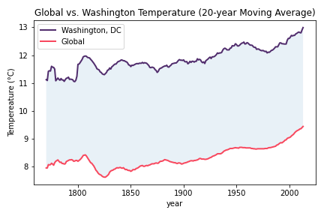

Figure 2- The line charts show the increase in temperature moving averages, both local and global.

Temperature Changes - 1980 to 2013

The most drastic change in temperatures can be observed after 1980. The local temperature moving average jumped from 12.1 °C to 12.99 °C, a jumped of **≈** 0.89 °C. Global Temperatures moving averages also jumped from 8.68 °C to 9.44 °C, a jumped of **≈** 0.76 °C.

Using linear regressions, we formed temperature (T) equations.

1. Washington, DC:  
   T (°C) = - 38.147 + 0.0254 (year)
2. Global:  
   T (°C) = - 40.899 + 0.0249 (year)

At this rate, by 2050 temperatures in Washington and globally will average 13.7 °C and 10.14 °C.

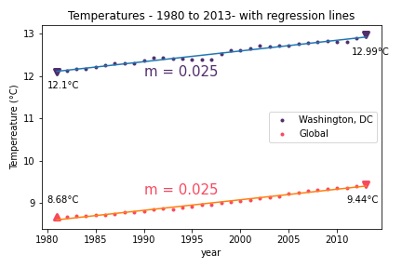

Figure 3 Local and global temperatures show an increase with linear approximations with slopes of m = 0.25.

Conclusions

From this analysis we conclude the following:

1. Moving averages provide a valuable tool when analyzing trends in data rather than localized details. Figure 1 clearly shows that the trends are easier to observe while displaying fidelity to the original data.
2. We can conclusively assert that the provided data shows temperatures are rising at a city and global level, particularly since 1980, where the temperatures jumped by almost one °C (0.89 °C locally and 0.76 °C globally).
3. The temperature changes since 1980 are particularly worrisome, particularly for future temperatures.   
   At the current rate, temperatures by 2050 will pass ten °C globally, and thirteen °C locally.
4. We should further study other cities temperature trends as compared to global temperatures, particularly as in correlation between latitude or longitude, continent, etc.